Monday | Tuesday | Wednesday | Thursday | Friday
4:00-4:45  Baby Ballet  (3-4 yr. olds) | 4:00-4:45  Itty Bitty Ballet/Tap  (4 yr. olds) | 4:15-5:00  Baby Ballet  (3-4 yr. olds)
5:00-5:45  Itty Bitty Ballet/Tap  (4 yr. olds) | 5:00-5:45  Baby Ballet  (3-4 yr. olds) | 5:00-6:00  Ballet/Tap  (5-6 yr. olds) | 5:15-6:00  Ballet I/II  (6-7 yr. olds) | Private Lessons
6:00-6:45  Tap II/III  (7-9 yr. olds) | 6:00-7:00  Ballet/Tap  (3-4 yr. olds) | 6:00-6:45  Jazz I/II  (6-7 yr. olds) | 6:00-6:45  Tap I/II  (6-7 yr. olds)
6:45-7:15  Jazz II/III  (7-9 yr. olds) | 7:00-7:45  Beg. Hip Hop  (8-10 yr. olds) | 6:45-7:30  Competition Practice | 7:00-7:45  Ballet II/III  (7-9 yr. olds)
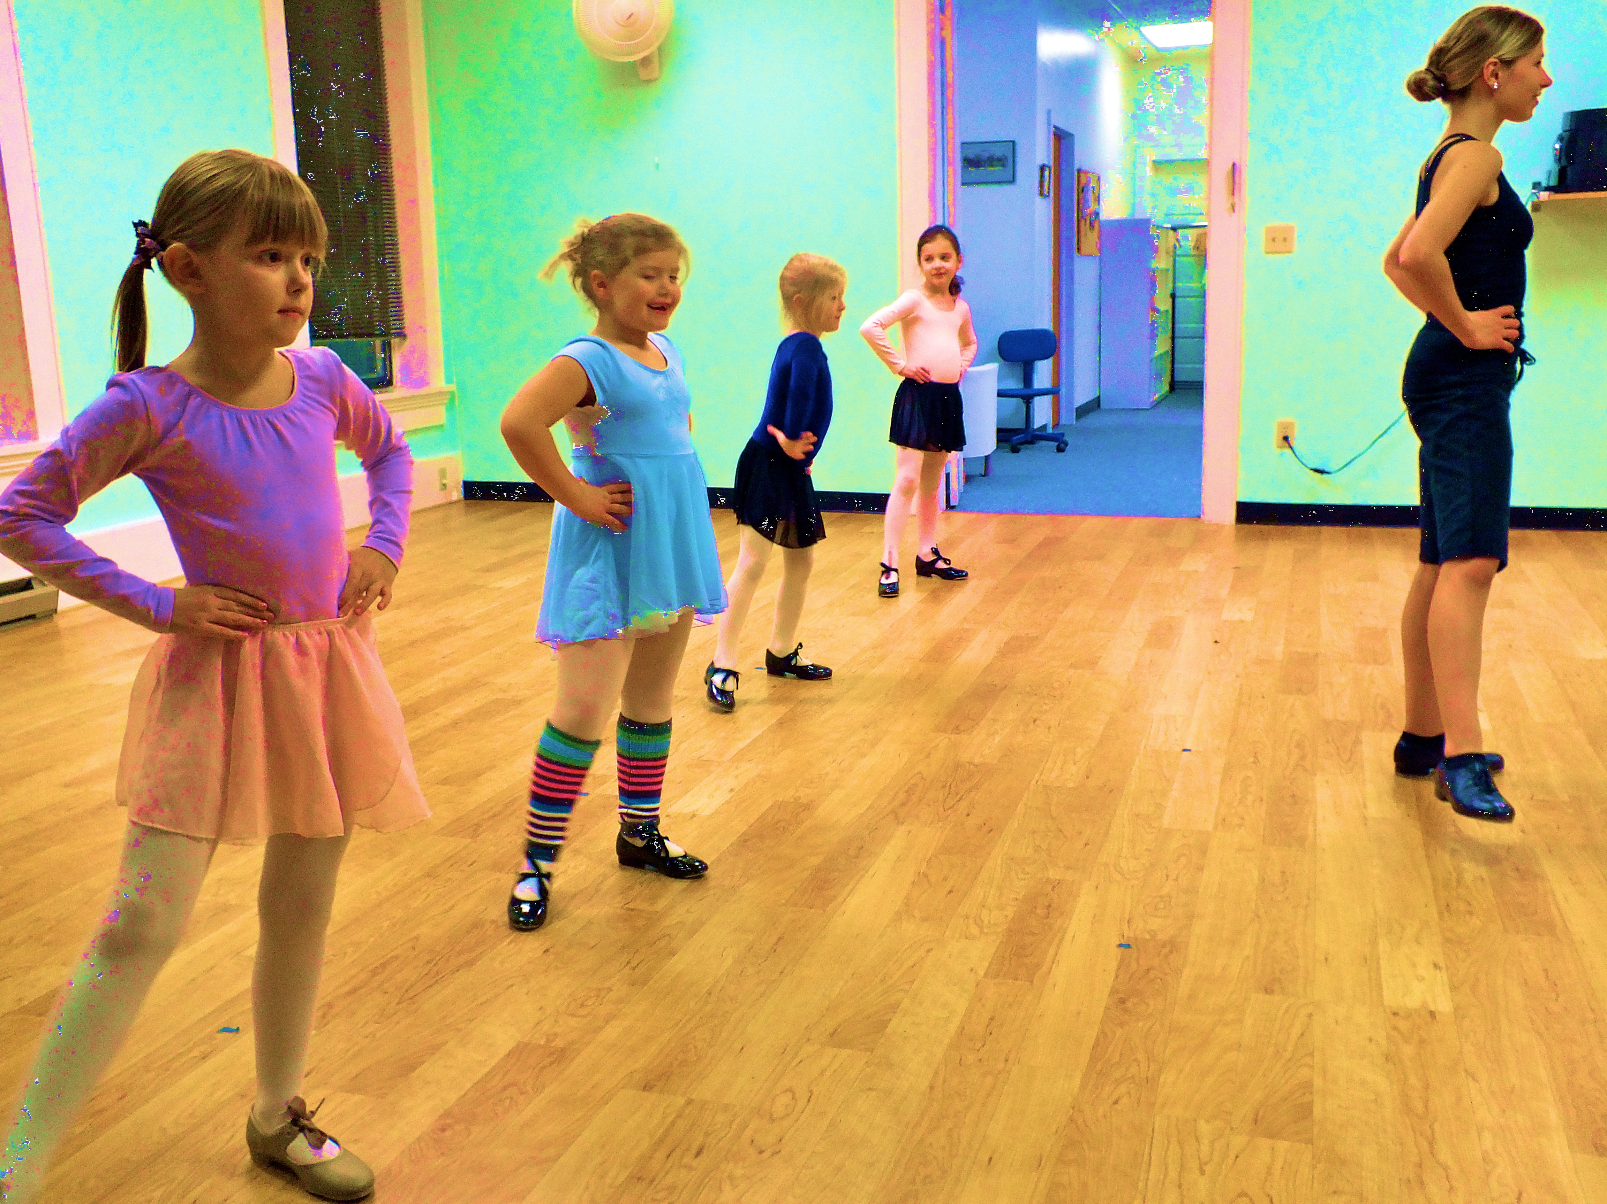

Christine Rozolis www.downtowndance.org (Phone): 570.768.9379. (Email): downtowndancepa@gmail.com

Full
Full
Full
Full

